**2014**



PROJECT TITLE: Toy Kingdom E-Commerce Project

STUDENT NAME: Myo Thet Tun

STUDENT ID: 018800021524

CLASS CODE: P08Sep14IT210A

LECTURER NAME: Shwe Yee Than

SUBJECT CODE: IT210

SUBJECT: Essentials of E-Commerce

SUBMISSION DATE: 26-Nov-2014

**TABLE OF CONTENTS**

**1. BUSINESS PLAN** 3

1.1 Company Profile 3

1.2 Organization Chart 3

1.3 Existing System and Problem Background 4

1.4 Target Audience 5

1.5 Objectives 5

1.6 Domain Name 5

**2. COSTS ANALYSIS AND BUDGETING** 6

2.1 Hardware 6

2.1.1 Workstation 6

2.1.2 Monitor 7

2.1.3 Server 8

2.1.4 Printer 9

2.1.5 Ethernet Hub 10

2.1.6 Router 11

2.1.7 Cable 12

2.2 Software 13

2.2.1 Microsoft Windows Server 2012 R2 13

2.2.2 Microsoft SQL Server 2012 13

2.2.3 AVG Internet Security 2015 13

2.3 Hosting Service and Domain 14

2.4 Site Development Cost 14

2.5 Communication Cost 15

2.6 Budgeting 16

**3. E-COMMERCE INFRASTRUCTURE** 17

3.1 Web Server 17

3.2 Database Server 17

3.3 Web Hosting Facilities 17

3.4 Site Development 17

3.5 Marketing Strategy 18

3.6 Physical Design (Intranet) 18

3.6.1 Physical Design and Flow 18

3.6.2 Page Design 19

**4. SECURITY AND IMPLEMENTAION** 22

4.1 Threats to Network Data 22

4.2 Firewall 22

4.3 Password and Policy 22

4.4 Fault Tolerance 22

4.5 Back Up 22

4.6 Crypto System 23

**5. CONCLUSION** 24

5.1 Strengths 24

5.2 Weaknesses 24

5.3 Future Enhancements 24

**6. REFERENCE LIST** 25

**1. BUSINESS PLAN**

**1.1 Company Profile**

Toy Kingdom is a big toy company which is located in Yangon, Myanmar. It was founded in 2010. It mainly sells a various range of toys including cars, planes and tanks. Toys can be categorized as with or without Radio control. Since it was started, it was running with a few numbers of staffs. Now, Over 4 years, the shop is getting more and more famous and the boss wants to expand the business. Because of the very fast-changing technology, the boss wants to make his products can be seen and available 24/7 to all over the country. With the ability of E-commerce and web technology, we can even make our products to reach to the customers living in the other side of world without actually need to visit to the shop.

**1.2 Organization Chart**

**1.3 Existing System and Problem Background**

Currently, the staffs have been doing all the work manually. That is, the staffs have to record every transaction manually in the Microsoft Excel Spreadsheets. So, it is a very time-consuming task and data entry errors are likely to be occurred because there is no data validation system. Because the company has to heavily rely on E-mail, fax and phone calls from customers, the staffs have to handle bunch of responses and enquires every day.

**Slow Response to Customer Enquiries** - Enquiries made by customers are mostly from e-mail or fax. Because of the structure of the business system is not well-organize, it may take one or two days to reply the customers' mail or fax. Sometimes, the staff may misread or skip the mail as the system may regard this as junk mail. Sometimes, checking for availability of stocks may take an hour or more when a customer make an order or make an enquiry of specific stock.

**Difficulty in Maintenance of Records** – As records are stored in Excel Spreadsheets manually, they are very difficult to be maintained or amended when needed. For retrieval of members’ information records, it is also a very time-consuming task. Because there is no specific search function, the staff has to find the required record manually.

**Duplication of data** – Because of not well-organize in storing data records, duplication can be occurred very often.

**Cost in advertising** – Company has been spending a lot of money in advertising in multimedia and TV commercial, and in printing unnecessary brochures. And, every time the new product is out, brochures and catalogues are to be re-printed again.

**Market limitation** – Currently, the company has a very limited market which is only in the country region. The company’s expect to grow up as a globally-recognize company is still a big challenge.

**1.4 Target Audience**

As this company’s main products are toys, their target audiences are young kids and teenagers. For the remote controlled toys, there are adults of ages between 20 and 35 are also included in their target audience as well. Now, with the advantage of fast growing technology and with the help of E-commerce system, the company is expecting to expand its market limit to the whole of Asia region, and, lastly, to the whole world.

**1.5 Objectives**

The main objective of the proposed E-commerce system is to solve all the problems that the company is currently facing with. With the photo and clearly stated detailed information of the product, customers can easily view the product’s information on the web without enquiring or calling to the company. And customers can make orders for the product straight away on the web. Moreover, customers can always get the most recent updates and information because of real-time update on the web site. When the new product is out, we can easily just put in the new product information and the user can view the new product right away. So, the problems of re-printing catalogues again and printing unnecessary brochures can be terminated. The company can reduce a lot of cost for advertising here. Members’ information can easily be updated when needed. It will be much easier to maintain the records than in Excel spreadsheet. Finally, the products’ information on the web is available 24/7 and customers can view the product or make the order at any time. And the market limitation of the company will become everywhere in the world that the internet access is available.

**1.6 Domain Name**

Domain name should be simple and easy to memorize to the people who visit our page. The best domain name suggested for the company is [**http://www.toykingdom.com**](http://www.toykingdom.com).

**2. COSTS ANALYSIS AND BUDGETING**

As we all notice that almost all of the products nowadays have their web address printed on their cover packages, internet is the most widely used media to make the world knows their products. Therefore, the computers that are used by the programmers and staffs and the servers that are running must be very good ones.

**2.1 Hardware**

**2.1.1 Workstation**

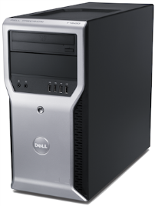

**Dell Precision T1600 Workstation**

**Processor**: 3.4-GHz quad-core Xeon (E3-1270).

**Operating system**: 64-bit version of Windows 7 Professional with XP mode.

**Graphics card**: NVIDIA Quadro 2000 includes 1 GB GDDR5 memory.

**RAM**: 4 GB of 1,333 MHz, DDR3 SDRAM

**Storage**: 500-GB SATA hard drives (16 MB cache).

**Extra**: 16 x DVD+/- RW drive, standard keyboard, optical mouse, internal speaker, network adapter, and an integrated sound card.

**Dimension and weight**: 14.2" x 6.9" x 17.0", weighs 19.7 lb and includes ten external USB 2.0 ports.

**Price per unit**: S$1,250

**Total price for 20 units**: S$1,250 x 20 = **S$25,000**

**2.1.2 Monitor**

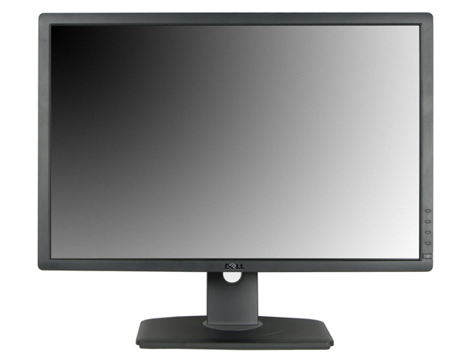

**Dell UltraSharp U2412M Monitor S370**

**Size**: 24 inches

**Resolution**: 1920x1200 pixels

**Response time**: 8ms

**Contrast ratio**: 1000:1

**Brightness**: 300 cd/m2

**Inputs**: VGA, Display Port, DVI

**Price per unit**: S$256

**Total price for 22 units**: S$256 x 22 = **S$5,632**

**2.1.3 Server**

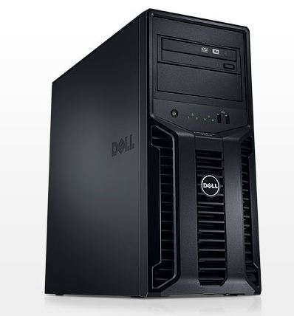

**Dell PowerEdge T110 compact tower server**

Intel® Xeon Processor E3-1220v2, 3.10 GHz,

Windows server standard 2012

32GB 1333MHz DUAL Ranked Memory

C1 No Raid with On-board SATA Controller, 1-4 3.5" SATA Drives

3 x 2TB 3.5-inch 7.2K RPM SATA II Hard Drive RAID 5

16x SATA DVD + / - RW Drive

Dell U2312HM 23" LED Monitor

3 Yrs On-site Service Support

**Price per unit**: S$1,684

**Total Price for 2 units:** S$1,684 x 2 = **S$3,368**

**2.1.4 Printer**

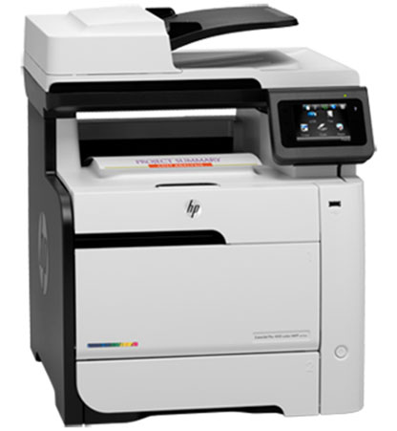

**HP LaserJet Pro 400 color MFP M475dn Printer**

**Functions**: Print, copy, scan, fax

**Print Speed**: (Normal)Up to 20 ppm

**Print Quality**: Up to 600 dpi (black)

Up to 600 dpi (color)

**Display**: 3.5" (8.89 cm) touchscreen, LCD (color graphics)

**Processor**: 600 MHz Warranty2 years of warranty on hardware

**Price per unit**: S$1,499

**Total Price for 2 units:** S$1,499 x 2 = **S$2,998**

**2.1.5 Ethernet Hub**

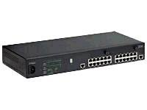

**08L2965 IBM 10/100 Stackable Ethernet 24 Ports RJ-45 Master Hub**

Device Type Hub - 24 ports - managed - stackable

Enclosure Type Desktop

Interfaces Fast Ethernet

Ports 24 x 10/100

Remote Management Protocol SNMP, RMON

Features Full duplex capability, uplink

Compliant Standards IEEE 802.3, IEEE 802.3u

Power AC 120 V ( 50/60 Hz )

Dimensions (WxDxH) 17.2 in x 8.5 in x 2.5 in

Weight 8.4 lbs

Color Black

**Price per unit**: S$320

**Total Price** **S$320**

**2.1.6 Router**

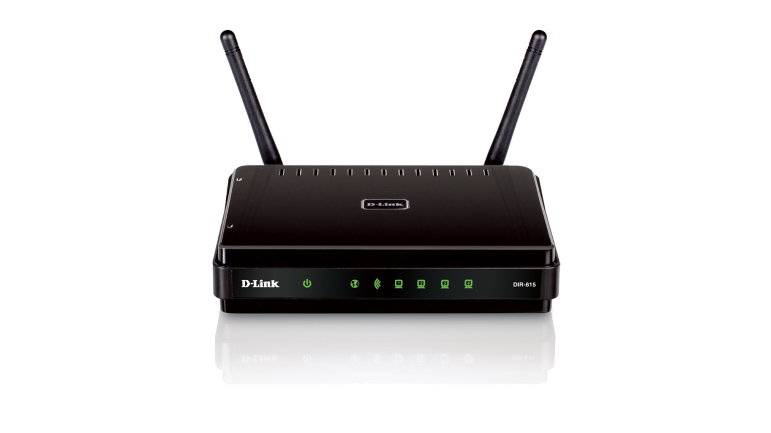

**D-LINK DIR-615 ROUTER**

Fast Ethernet 6 Ports

Wireless Speed Wireless N 300

**Price per unit: S$120**

**Total Price: S$120**

**2.1.7 Cable**

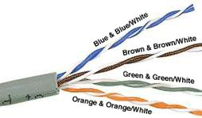

Unshielded twisted pair cables are most widely used in network cabling. The cable has no shielding material between the pairs of wires and the cable’s outside jacket. It consists of one or more pairs of copper wires where each pair of wires is twisted around each other. By twisting the wires, it is less prone to interference from other nearby electrical signals such as signals from photocopier machine. UTP cables are not expensive to buy and relatively easy to install and flexible compare to other type of cables. It can reliably transmit information up to a few hundred feet. Category 5 which is known as 100Base T can transmit up to 100 Mbps. For this company’s network transfers relatively large amounts of data signals frequently, category 5 cable is the most suitable cable to choose. Both ends of UTP cables are joined with RJ-45 connectors which are used to attach to workstations or other networking devices.

**Category 5 UTP cable 305 meter**

**Price for 305 meter: S$200**

Quantity: 3

**Total Price for 915 meter:** S$200 x 3 = **S$600**

**2.2 Software**

**2.2.1 Microsoft Windows Server 2012 R2**



Windows Server 2012 features virtualization, storage, virtual desktop infrastructure and access, management and network security can also be improved.

**Price: S$759**

**2.2.2 Microsoft SQL Server 2012**



It is among one of the best software for data control management. It has many features to store data and manage data for business intelligent and basic data management.

**Price: S$3189**

**2.2.3 AVG Internet Security 2015**



### It is one of the best solution for protecting antivirus and anti-malware and other malicious programs like rootkit. It also provides email scanner, protective cloud scanner, social networking protection system, communication network protecting system, anti-spam for email, AVG online shield and enhanced firewall and many features.

**Price: S$55**

**2.3 Hosting Service and Domain Registration**

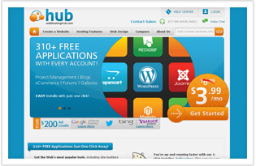

**Web Hosting Hub**

There are plenty of web hosting providers and domain name registration services on the internet. Among them, “Web hosting hub” is one of the great site to host your website. It is recommended for small businesses and with many features like free backup tools to restore your site any time, fast loading feature, one account can host multiple websites, and more. It is a reliable hosting provider with affordable price.

**Price: S$120 per year**

**2.4 Site Development Cost**

Initial Development Cost

Initial development costs for standard e-commerce site and features list are as follows.

7-9 web pages of text

Inclusive of 20 to 40 images

Inclusive of 5 external links to other websites and 5 internal links

**Cost: S$1200**

Maintenance Cost

Inclusive of monthly maintenance and update service

**Cost per year: S$2000**

Additional Cost

For every extra page

**Cost: S$50**

For every extra image

**Cost: S$10**

For every extra link

**Cost: S$10**

**2.5 Communication Cost**

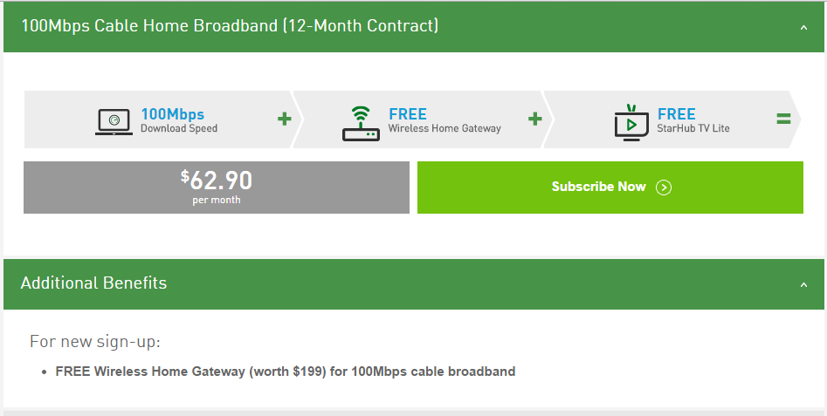

Starhub internet service provider is a popular internet service provider and the price for the plan is also a relatively affordable price with S$62.90 per month for 1 year contract for 100Mbps. It’s internet service is reliable and one of the most popular internet service providers in the region.

Cost: **S$62.91** per month

**Total cost for 1 year**: S$62.91 x 12 = **S$755**

**2.6 Budgeting**

**Hardware Cost**

|  |  |  |  |
| --- | --- | --- | --- |
| **Description** | **Price** | **Quantity** | **Total** |
| Dell Precision T1600 Workstation | S$1,250 | 20 | S$25,000 |
| Dell UltraSharp U2412M Monitor S370 | S$256 | 22 | S$5,632 |
| Dell PowerEdge T110 compact tower server | S$1,684 | 2 | S$3,368 |
| HP LaserJet Pro 400 color MFP M475dn Printer | S$1,499 | 2 | S$2,998 |
| 08L2965 IBM 10/100 Stackable Ethernet 24 Ports RJ-45 Master Hub | S$320 | 1 | S$320 |
| D-LINK DIR-615 ROUTER | S$120 | 1 | S$120 |
| Category 5 UTP cable 305 meter | S$200 | 3 | S$600 |
| **Software Total Cost** |  |  | **S$38,038** |

**Software Cost**

|  |  |  |  |
| --- | --- | --- | --- |
| **Description** | **Price** | **Quantity** | **Total** |
| Microsoft Windows Server 2012 R2 | S$759 | 1 | S$759 |
| Microsoft SQL Server 2012 | S$3,189 | 1 | S$3,189 |
| AVG Internet Security 2015 | S$55 | 1 | S$55 |
| **Hardware Total Cost** |  |  | **S$4,003** |

**Communication Cost**

|  |  |
| --- | --- |
| **Description** | **Price** |
| Web Hosting Hub Hosting Service and Domain Registration | S$120 |
| Site development cost | S$1,200 |
| Site maintenance cost | S$2,000 |
| Communication cost | S$755 |
| **Communication Total Cost** | **S$4,075** |

**Grand Total Cost**

|  |  |
| --- | --- |
| Software Total Cost | S$38,038 |
| Hardware Total Cost | S$4,003 |
| Communication Total Cost | S$4,075 |
| **Grand Total Cost** | **S$4,6116** |

**3. E-COMMERCE INFRASTRUCTURE**

**3.1 Web Server**

The most common task for a web server is to host websites. A web server's primary role is to process the requests from clients via HTTP (Hyper Text Transfer Protocol) and the web server responds back with web pages containing HTML, styles and scripts. If it is unable to respond the request, it will display an error message to the client's request. All web servers have IP addresses and this can also be a domain name as this company web address "http://www.toykingdom.com". Additionally, a web server can also be used as a storage machine.

We recommend using Microsoft Internet Information Server (IIS) here as it comes with Windows NT based software as a bundled (free) software. IIS 8.5 is already included in Windows Server 2012 R2 which features includes ‘Idle worker-Process page-out’, Enhanced Logging, Dynamic Site Activation, ETW logging and Automatic Certificate Rebind.

**3.2 Database Server**

Microsoft SQL 2012 Server is used because of high volume data processing in company’s products’ information and customer details information. The important processes for data management such as adding, deleting, updating to tables, creating new tables and extracting queries, all processes can be done in this software neatly and efficiently.

**3.3** **Web Hosting Facilities**

For both individual and enterprise web sites, web hosting facilities allows them to make their websites to be visible and accessible on the internet. There are a few varieties of web hosting services. The most common services are web page and file hosting services where files are uploaded by FTP (File Transfer Protocol) through a web interface. There are two categories of web hosting service available, personal hosting and business hosting. Personal hosting is usually an inexpensive, advertisement sponsored, or even free with some storage and bandwidth limitations. A single page or a few pages are usually enough for a personal web hosting. But for a more complicated business web pages will definitely be more costly as it includes supporting of database and application development platform such as PHP, Perl, Ruby and ASP.Net.

**3.4 Site Development**

There is a wide variety of web creating tools to choose from when creating web sites. HTML, JavaScript, Microsoft FrontPage are the most common tools and the most effective tools to be used for creating this web site.

**3.5 Marketing Strategy**

The most common functions to be included in an e-commerce site are -

1. Products catalogue display

2. Shopping carts

3. Banners

4. Search engine

Firstly, a customer will come to our page and be able to browse the home page which contains the most popular products and promotion items. Site navigation appears on the left pane of every page. So, the clients may go through the site wherever he wants to. From there, the client can go to the main product page which describes more detail about the product. Clients may directly go and buy at the shopping cart page which contains all products available to buy and delivery details information to be filled up by the client. Clients may want to register as a member by filling up the member registration form. Clients can also leave their comments or feedback for the company and products improvements.

**3.6 Physical Design (Intranet)**

**3.6.1 Physical Design and Flow**

Home

Complete Transaction

Make Payment

Fill Up Delivery Info;

About Us

Contact Us

Feedback

Member Registration

Shopping Cart

Product Details

Product Catalogue

**3.6.2 Page Design**

This is the site’s main home page and is also the first page when the user enters the site address ‘www.toykingdom.com’. Company logo and company name are shown on the banner and ‘sales promotion items and new products’ are displayed with offered prices to attract clients’ attention.

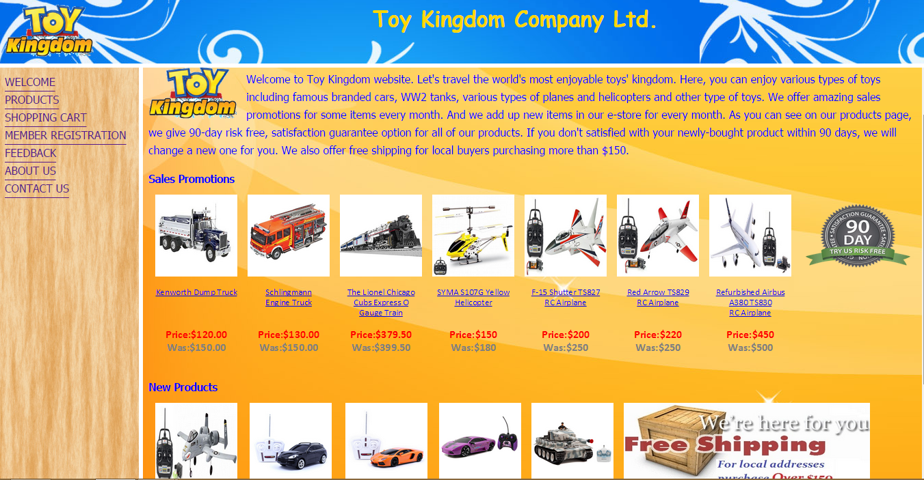

This is the main product page with all available products both in images and descriptions. The customer still can click every product description link to go to the specific product’s detail page.

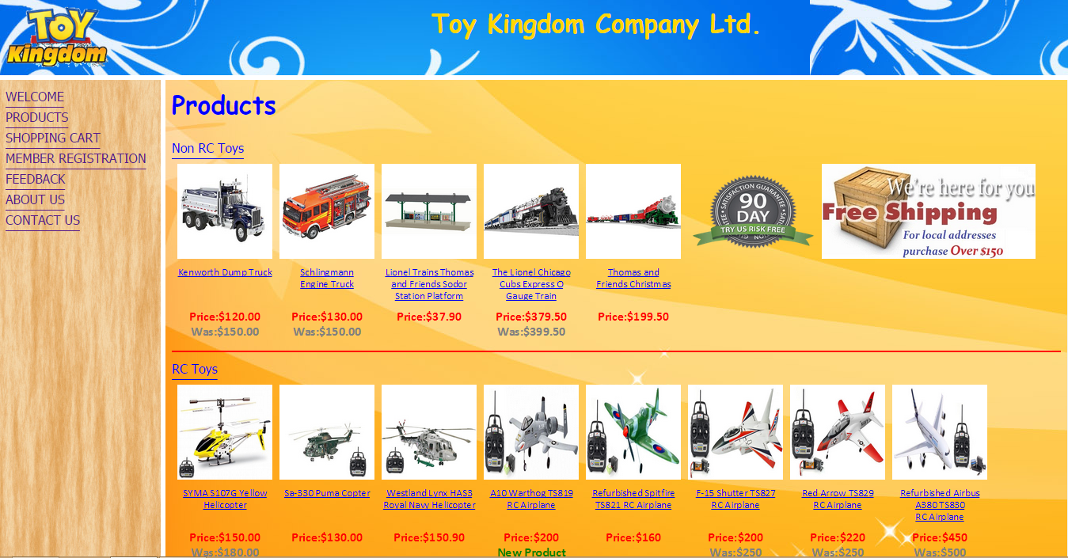

Below are the products detail pages for Non RC Toys and RC Toys.

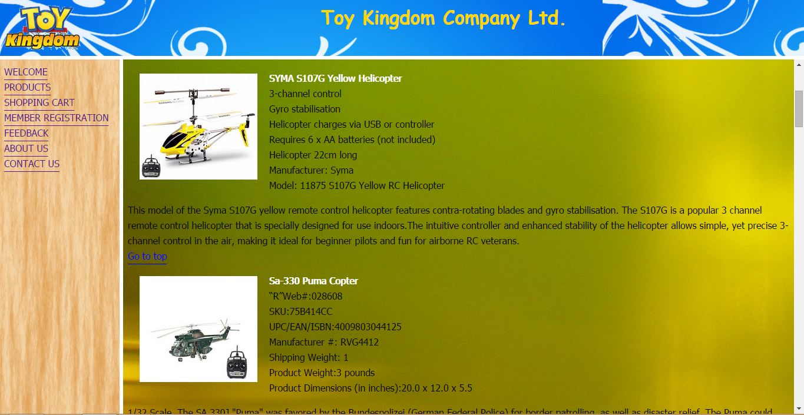

This pages show the larger photos of products with detailed specifications and descriptions.

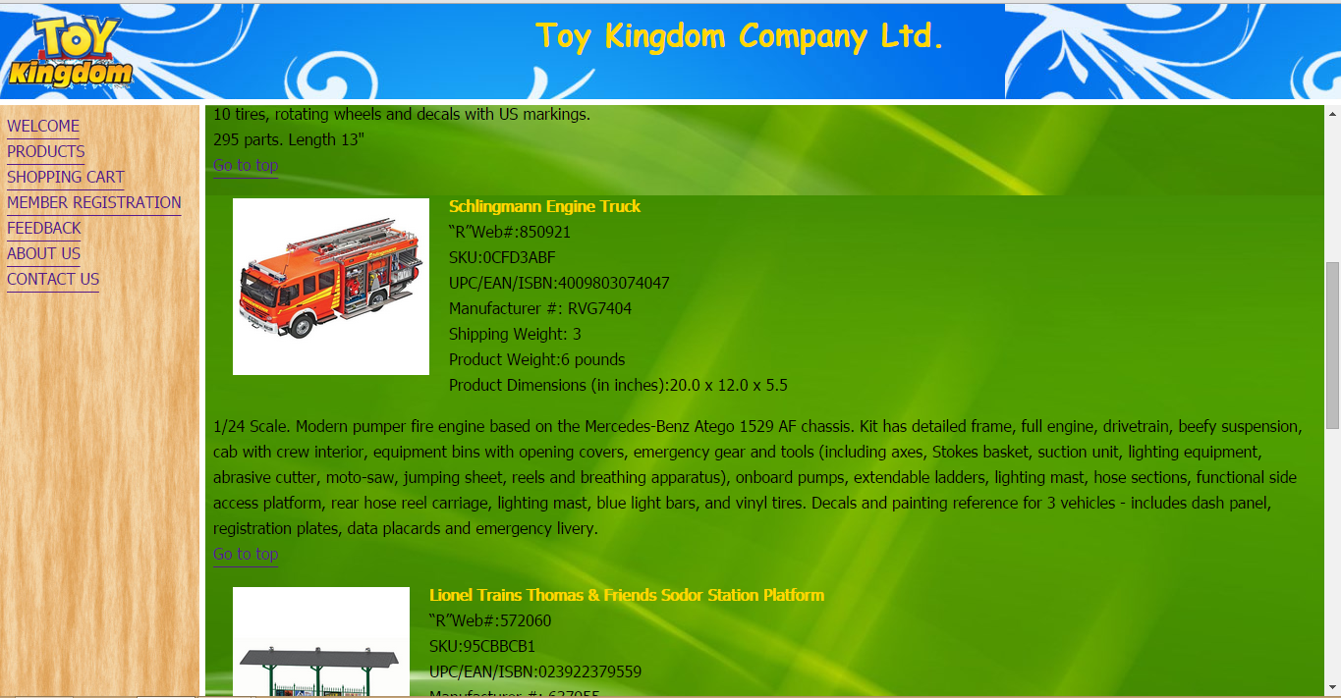

Member registration page allows customer to key in their information details.

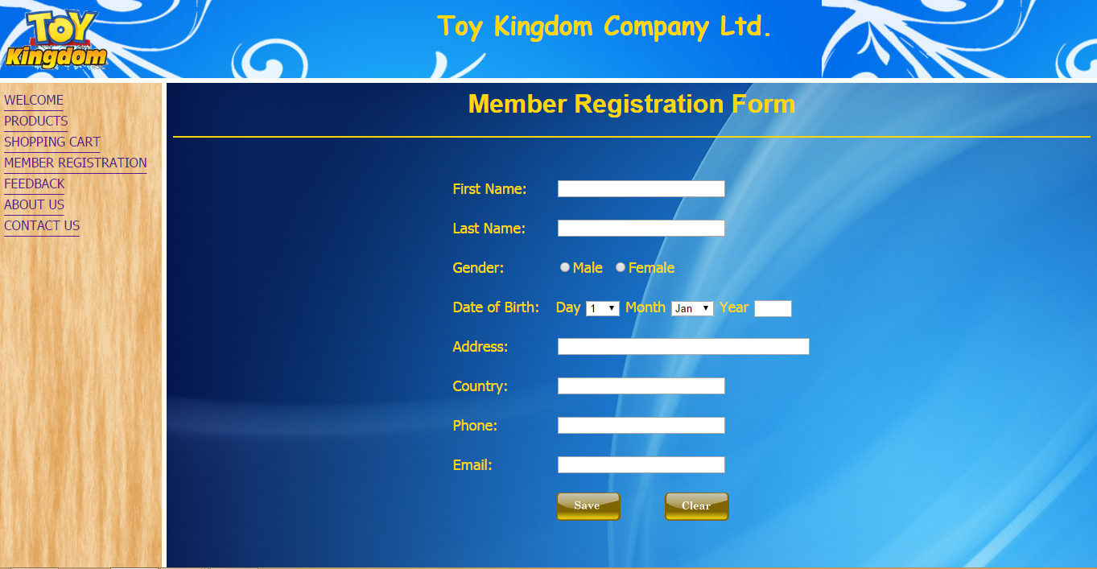

Shopping cart page allows customers to choose the specific products they want and calculates the total amount depending on customers’ choice. Customers need to fill up the delivery details form to submit an order. When the user submits the order form, payment detail form will appear and request for the information of the card to be charged and process the transaction. After that, transaction complete message will appear to inform the user the completion of transaction.

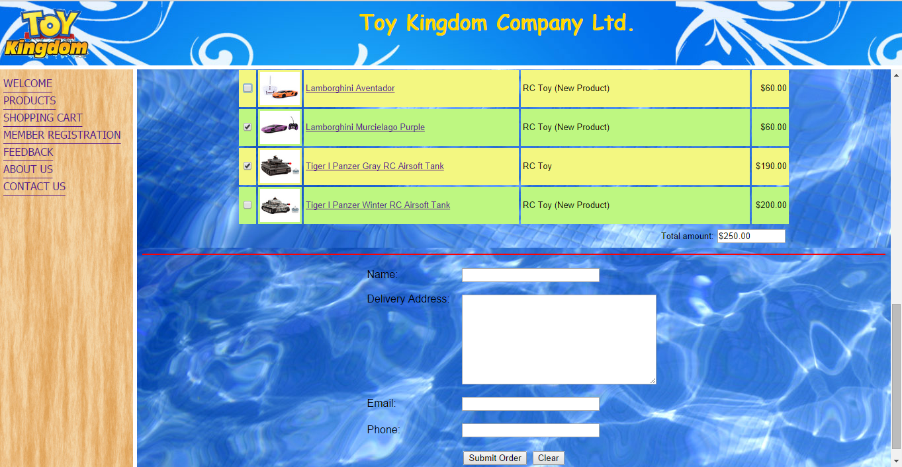

**4. SECURITY AND IMPLEMENTATION**

**4.1 Threats to network data**

There are many ways that data can be lost, stolen or destroyed. If data on a network is lost, a company could experience serious financial losses and reductions in employee productivity. Data can be stolen or destroyed by hackers and crackers. Virus or malicious programs can also attack the system. As an e-commerce web site, in order to perform secure online transactions and to protect users’ information, security becomes an important issue for both customer and company.

**4.2 Firewall**

A firewall is a first line defence to protect private data information. Firewall can prevent from unauthorized access to the server and to protect from being attacked by the malicious software or viruses because firewall screens and filters the incoming and outgoing data traffic. There are many types of firewall techniques to prevent from harmful potential threats from the internet. These techniques include Packet Filter, Application Gateway, Circuit-level Gateway and Proxy Server. Most firewalls use two or more techniques in real life situation.

**4.3 Password and Policy**

User ID and password are provided for each user to login to the site. The password will be expired after 90 days and user must change the password. The minimum password length is set to 8 characters and it must include alpha-numeric and special characters for better strength of passwords. Because of the password history log, recent passwords are unable to be reused.

**4.4 Fault Tolerance**

Fault tolerance systems are designed to recover back the data if the system failure or storage device failure occurs. The system has extra power supply that can maintain the power supply of servers or hubs if the current supply should fail. All the file servers, backup servers and hubs contain extra power supply system to ensure the system not to shut down because of the power supply failure.

**4.5 Back up**

A backup server is running for each network with regular daily basis back up system. Even if the system failure should occur, data can be retrieved until the previous day update.

**4.6 Crypto System**

Data encryption method is used when sending and receiving data on the network.

There are three types of encryption method used, namely Public Key Encryption, Private Key Encryption and Hash Coding. In case that other unauthorized person would catch the data signal and important information can be stolen. But, the person can only get the encrypted data information or unintelligible characters because the public key encryption method is used for the networks.

The sender uses his own private key to encrypt the data and uses the recipient’s public key to encrypt the data again and sends the data to the network. When the recipient receives the data message, he uses his own private key and the sender's public key to decrypt the data. So, it is quite safe to send and receive the data on the both networks.

**5. CONCLUSION**

An e-commerce site provides the easiest way to buy the products from our store without the barriers of time and distance. One can log on to the internet at any time from any part of the world and can sell or purchase almost everything online at a single click of the mouse. With more secure and efficient ways, and faster, too, to buy things online are provided in our e-commerce site, we believe that this will make our customers satisfied and more comfortable to browse our products and buy things easily. A good shopping cart design must be implemented with user-friendly shopping cart application logic. It should be convenient for customers to view the contents in their carts and should be able to remove or add items from their carts. Below are the strengths, weaknesses and future enhancements of the site.

**5.1 Strengths**

The web site contains so many images to provide clients the exact figure of how the product he or she wants looks like and the descriptions or names of the products are made up of hyperlink texts that linked to the site that shows the detail descriptions of the product specifications together with larger images of the products. Shopping cart page is made as simple and user friendly as possible. The customer just need to click the check boxes for the items they want to put into their carts and can check the total amount of costs at the same time.

**5.2 Weaknesses**

The hyperlinks for the product description should be able to go to the specific product description directly instead of going to the RC toys and non RC toys pages again and again then go to the specific product description. The shopping cart page should have a quantity text box for each product. Now, the customer can only buy one item unit for one product.

**5.3 Future Enhancements**

Hyperlinks for the product description will be able to go to the specific product detail directly and shopping cart page should be able to add the quantity for each item. The design of the product page and the detail description page should be improved to attract the client’s attention and to be a better quality of e-commerce web site.

**6. REFERENCE LIST**

**Books**

Paul Whitehead, Teach yourself Networking Visually

IT210 – Essentials of E-Commerce, Informatics Study Guide

**Web sites**

[www.webopedia.com](http://www.webopedia.com)

[www.wikipedia.com](http://www.wikipedia.com)

[www.webhostinghub.com](http://www.webhostinghub.com)

howtogetonline.tips

[www.dell.com](http://www.dell.com)

[www.cadalyst.com](http://www.cadalyst.com)

[www.amazon.com](http://www.amazon.com)

www8.hp.com

[www.markitx.com](http://www.markitx.com)

**\*\*\*\*\*\*\*\***